**Bank Management System in Java**

• Bank is the place place consumers feel a sense of security for their feature. In the bank, clients deposit and retract their services. Nowadays, directing a bank is a dull task upto the limit. So a bank administration scheme that reduces whole is essential. Also, today’s realm is a honest calculating planet and is succumbing faster and faster era-by-era.

Thus, considering duplicate essentialities, bureaucracy for bank administration has enhance inevitable that hopeful valuable in directing the bank more capably.

**Problem Statement:**

The Bank Management arrangement exists of the bank authority and the consumer. The executive will need to establish a new give reason for the client by record into their existent report. The system kills movements like forging a new report, examining the balance of the report, withdrawing, depositing, services transfers middle from two points two reports, and considering undertaking past.

* **Group Members:**

1. L. Keerthi Dhar Reddy – 2320030030
2. G. Sai teja – 2320030023
3. J. Venkat Manoj-2320030111
4. MSVS Sreekar -2320030025
5. V. Balaji Naidu – 2320030016

**System Design & Flow Chart:**

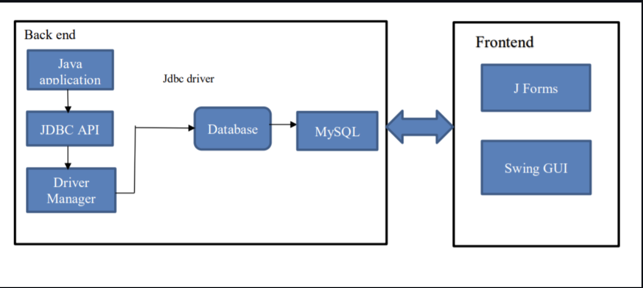

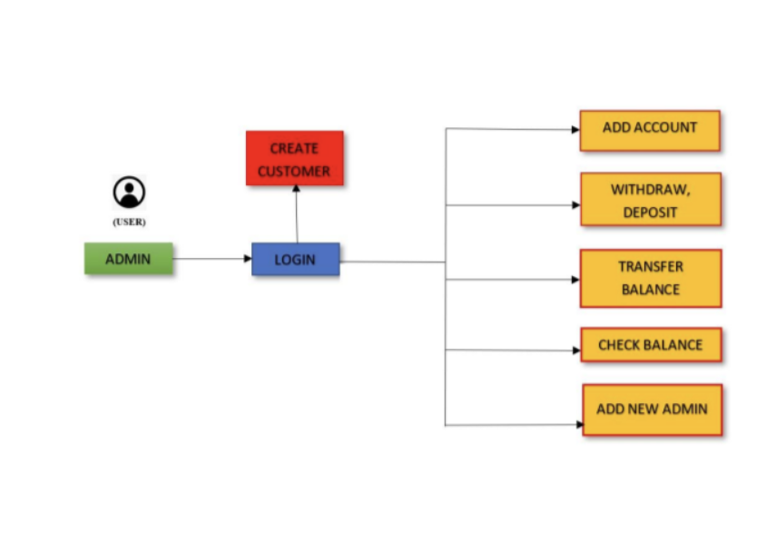

**System Requirements:**

Interpreters: Java and Java Database Connectivity(JDBC).

Software: Netbeans, Xampp.

Database: MySQL.

 Hardware: 10GB storage, 4gb ram 4.1.2

**Conclusion :**

**•**Bank administration plan is a virtualization of undertakings in investment arrangement.

The investment system uses manual active but when we use a bank administration scheme it is completely in essence and this process prevent physical labor and converts it in mechanical process.

Bank administration arrangement is conditional moment of truth accompanying veracity than usual bank arrangement.

It further reduces the human mistakes began by clerks or the client itself.

**References:**

<https://www.javatpoint.com/online-banking-project>

<https://projectsgeek.com/2016/02/complete-banking-system-java-project.html>